New Zealand Volcano Erupts and Leaves Multiple Deceased

Earlier on December 8th, a volcano in New Zealand erupted unexpectedly. There’s footage via users on Twitter of the massive smoke billowing out of the stratovolcano White Island. The volcano erupted whilst tons of cruise ship tourists were exploring the island. Approximately 47 people were on the island when the explosion happened causing thick black fumes to emit into the air. Volcanic ash is harmful for all sorts of life and in humans it causes a multitude of problems. Due to the ash having an insane amount of harmful aerosols and poisonous gases in it, the ash can cause all sorts of respiratory problems either short-term or long-term. The ash not only affects humans near the eruption, but can also harm people by travelling hundreds of miles away from the origin point. It gets much worse because acid rain can happen by these clouds. In White Island’s case, the volcano is separated from the rest of civilization by a huge chunk of ocean. This a real concern meaning rescue efforts would take forever to achieve. The island is 50 kilometers (31 miles) off the coast of Whakatane which is one of the closest points to the secluded island.

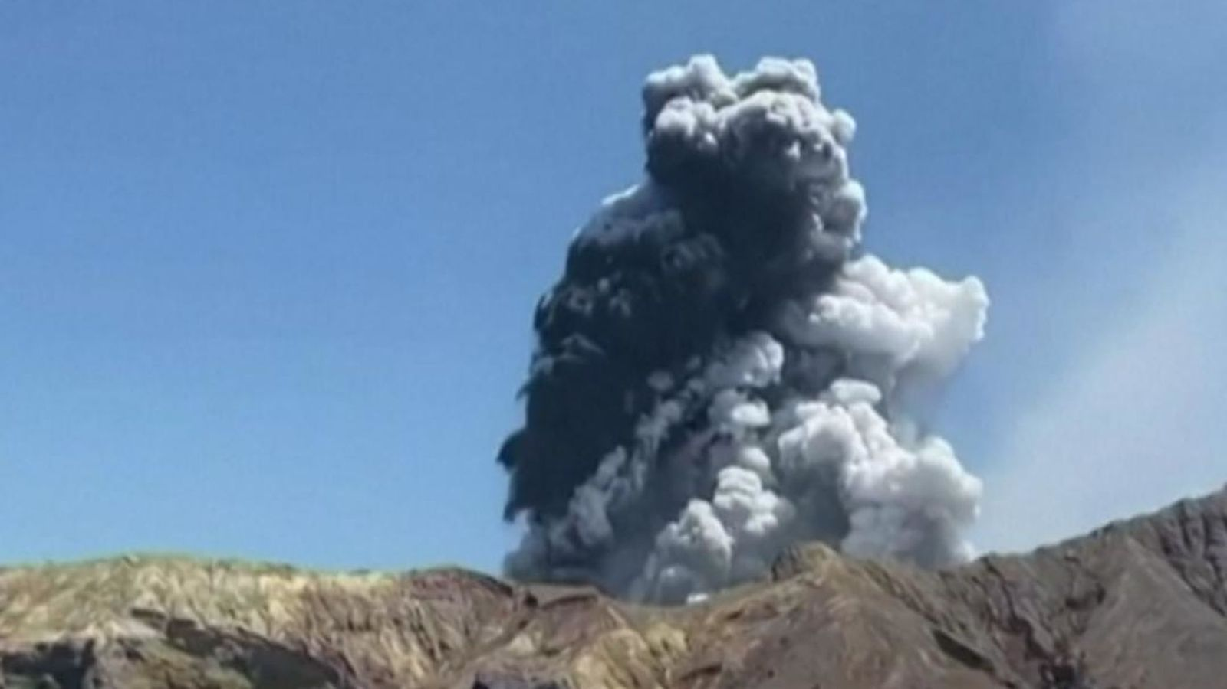

However, rescue efforts were made immediately to save the foreign visitors from Australia, United States, Malaysia, United Kingdom, and China. Supposedly there were no signs of life on the island after Tuesday morning which brings concerns to the families of the lost. As of the 12th, 8 have been pronounced dead, with 8 other people missing and are presumably dead. And 28 people have been put into hospitals, some of those people were flown out to Australia for treatment.

Apparently this friday, members of the New Zealand Defense Force will attempt to rescue or explore the island for the remaining missing on the island. They will do this from the naval vessel HMS NZ Wellington. But the rescue mission is still very risky due to the likelihood of volcanic activity being 50%. Let’s hope the best of the rescue team.